17th Acute Medical Emergencies Course
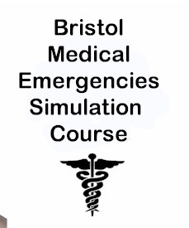

Friday 24th^{th} April 2015

Bristol Medical Simulation Centre
Post Graduate Medical Education Centre
Bristol Royal Infirmary

Booking Form

Name
Grade  (tick which one applies) | CMT 1  CMT 2  CMT 2b  ACCS (AIM year)  ACCS (any other year)  BBT  Unfortunately the course is not for F2 level doctors or non-trainee post doctors.
Trust
Mobile
Email
Dietary requirements | None  Specify _________________________________________________________
Deposit | CMT 1  CMT 2  CMT 2b  ACCS (AIM year)  Please enclose a cheque for £50 made payable to ‘Health Education South West.’  I understand that the place on the above course will not be secured until the form and monies are received. I understand the £50 will only be cashed if you fail to attend the course and therefore this cost cannot be claimed from your yearly study budget.  ________________________________(signed)________________________(date)
Payment | ACCS (any other year)  BBT  Please enclose a cheque for £50 made payable to ‘Health Education England’.  I understand that the place on the above course will not be secured until the form and monies are received. I understand the £50 I will be cashed by the deanery on receipt. I understand when I attend the course I will be given a receipt and a certificate of attendance so you can claim the monies back from your study budget.  ________________________________(signed)________________________(date)

Please return the completed form and cheque to:
Emma Stratton, 49 Arbutus Drive, Coombe Dingle, Bristol, BS9 2PW

